CSCE 5565 Quiz 3 - Fall 2023

# Question 1 (10 points)

Provide an example of security requirements and illustrate its satisfaction of each of the three criteria for adequate security requirements.

Answer:

* Strong passwords
* MFA
* Logs needs to secured
* Data need to be encrypted over network
* Identify critical assets
* Define security goals
* Identify threats

Criteria:

* Comply with definition
* Need to satisfied
* Adaptability
* Can be measured.

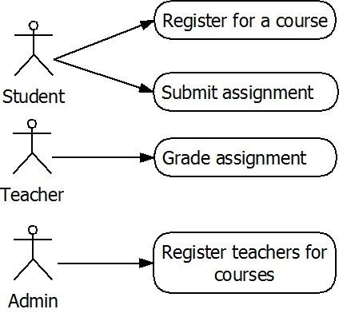

Figure 1: A sample use case of a marking system.

You are provided with Figure 1, representing a use case diagram for a school’s marking system.

List three (3) security requirements that are essential for the development of a secure marking system.

Answer

* Authentication
* Authorized access to submitted assignments
* Students will only option to submit assignment and should not be able to view other students submission
* Teacher can only see students from his/her class only.

Explain the complete mediation design principle in one or two statements, and provide an illustrative example.

Answer:

Every access to every object must be checked for authority.

OR

Every access to a resource must be checked against the access control mechanism every single time, ensuring permissions haven't changed since the last check.

Examples:

* File access
* Sessions
* Accessing company’s resources
* Connecting to the Network

You are building a new desktop software that you plan to distribute for Mac users. What security mechanisms do you need to enforce to ensure that malware does not change the behavior of your software?

Answer:

* I must be authorized to develop software for Mac’s
* Need to follow the guidelines set by apple when developing the application
* The Input from user must be validated before used in the system
* The application should be able to work with minimum requirements. So, it doesn’t affect the overall performance of the system